|  |  |
| --- | --- |
| **Envirous**  Vol. 6, No. 1, September, 2025, pp. 28-34  Halaman Beranda Jurnal: http://envirous.upnjatim.ac.id/  e-ISSN 2777-1032 p-ISSN 2777-1040 |  |
|  |  |

|  |  |  |  |
| --- | --- | --- | --- |
| **Redesign Planning of B3 Waste Temporary Storage Site (TPS) of PT X Located in Pasuruan Industrial Estate Rembang (PIER)** | | |  |
| Ahmad Baihaqi Yudhistira1 Muhammad Abdus Salam Jawwad1* | | |  |
| 1Program Studi Teknik Lingkungan, Universitas Pembangunan Nasional “Veteran” Jawa Timur  Email Korespondensi: muhammad.abdus.tl[@upnjatim.ac.id](mailto:muhammad.abdus.tl@upnjatim.ac.id) | | | |
| **Diterima:** 22-05-2025  **Disetujui:** 23-06-2025 **Diterbitkan:** 06-10-2025  **Kata Kunci:** limbah B3, tempat penyimpanan sementara limbah B3, redesain, industri, pengelolaan limbah |  | **ABSTRAK** | |
|  |
|  | PT X merupakan perusahaan yang bergerak di bidang industri dan perdagangan produk farmasi, serta jasa pengujian laboratorium di bidang pakan ternak. PT X memiliki luas lahan total yang dikuasai sebesar 1,2 hm2 dan total produksi sebesar 15.000 ton/tahun dengan kondisi riil sebesar 13.500 ton/tahun dengan jenis premiks untuk makanan hewan. Kedepannya, PT X berencana untuk membuka jasa pengujian laboratorium di bidang pakan ternak. Oleh karena itu, perlu dilakukan desain ulang bangunan TPS Limbah B3 perusahaan agar sesuai dengan PP No. 22 Tahun 2021 dan PermenLHK No. 6 Tahun 2021. Jurnal ini bertujuan untuk mendesain ulang tempat penampungan sementara limbah B3 PT X agar memenuhi peraturan yang telah ditetapkan dan memperbaiki kegiatan penyimpanan limbah B3 di PT X. Jurnal penelitian ini diawali dengan mengumpulkan data dari Rincian Teknis Limbah B3 PT X serta survei lapangan, lalu perhitungan, hingga perancangan. Berdasarkan data jumlah keluaran Limbah B3, kapasitas penyimpanan TPS Limbah B3 di PT X dapat dikatakan masih belum sesuai dengan peraturan yang berlaku. Hasil dari jurnal mencakup perubahan volume tempat penyimpanan sementara limbah B3, penambahan ventilasi, beserta pengemasan limbah B3 yang sesuai dengan regulasi yang berlaku. | |
|  |
| ***Received:*** *22-05-2025*  ***Accepted:*** *23-06-2025* ***Published:*** *06-10-2025*  ***Keywords:***  *hazardous waste, hazardous waste temporary storage, redesign, industrial, waste management* |  | ***ABSTRACT***  *PT X is a company that runs in the business of industry and trade in pharmaceutical products, as well as laboratory testing services in the animal feed sector. PT X has a total land area of 1.2 hm2 and a total production of 15,000 tons/year with actual conditions of 13,500 tons/year with types of premixes for animal feed. In the future, PT X plans to open laboratory testing services in the animal feed sector. Therefore, it is necessary to redesign the company's B3 Waste TPS building to comply with PP No. 22 of 2021 and PermenLHK No. 6 of 2021. This journal is aimed at redesigning PT X’s B3 waste temporary storage site so that it meets the established regulations and improves B3 waste storage activities at PT X. This research journal begins with collecting data, type, and characteristics of hazardous waste. Based on data on the amount of B3 Waste output, the storage capacity of the B3 Waste TPS at PT X can be said to still not be in accordance with applicable regulations. The results of the journal include changes in the volume of temporary storage for hazardous waste, the addition of ventilation, and the packaging of hazardous waste in accordance with applicable regulations.* | |
|  |

# 1. INTRODUCTION

Hazardous and toxic waste (B3) is the residue of a business and/or activity that contains hazardous and toxic materials (PermenLHK No. 6, 2021). Government Regulation Number 101 of 2014 concerning Waste Management Hazardous and Toxic Materials defines Hazardous and Toxic Materials (B3) as harmful substances, energy, and/or other components that due to their nature, concentration, and/or amount, either directly or indirectly, can pollute and/or damage the environment, and/or endanger the environment, health, and the survival of humans and other living things (Khurnia, 2018)

Waste can come from various activities carried out in the company. Waste has several characteristics, namely explosive, flammable, reactive, infectious, corrosive, and also toxic. If these compounds enter the human body, it can lead to disruption of body functions both metabolism and other disorders (H. Kusdiantoro, 2014). Hazardous Waste Management must begin when the waste is first produced and continue until the waste is disposed of or destroyed (Wardhani & Rosmeiliyana, 2020).

PT X is a company that runs in the field of industry and trade in veterinary pharmaceutical products, as well as laboratory testing services in the animal feed sector. As the company progresses, the idea arises to open commercial services for testing laboratories for pharmaceutical products for animals, so that a redesign of the waste generated is needed. Based on the type of activities carried out by PT X, it produces hazardous and toxic (B3) waste, namely used battery waste, liquid waste from lab chemicals, expired materials or products, B3 packaging, used oil/lubricants, electronic waste, used cloth, and used filters. The waste generated from the company's production process has the potential to endanger the environment if it is not handled with various efforts, one of which is to make efforts to store B3 Waste in the B3 Waste Temporary Storage Site.

Based on the consideration of reports and field conditions regarding the management of hazardous waste generated, it turns out that PT X has not met the appropriate standards in providing and storing hazardous waste in the company's hazardous waste site if PT X wants to build a testing laboratory. Good hazardous waste management will help reduce hazards and negative effects on humans and the environment (Nurhayati, 2023). Therefore, this journal is aimed at redesigning PT X’s B3 waste temporary storage site so that it meets the established regulations andimproves B3 waste storage activities at PT X.

# 2. **MATERIAL AND METHOD**

The lack of a good management system can lead to hazardous waste treatment errors and negative impacts on humans and the environment (Aiana, 2020). In designing the B3 Waste Temporary Storage Site, what needs to be done is to collect the data needed, both the existing conditions of the company and the details of the types of waste produced. The data needed can come from primary data, and also secondary data. In carrying out hazardous waste management, it is necessary to pay attention to the hierarchy of hazardous waste management, among others, by seeking reduction at the source, processing materials, substituting materials, regulating activity operations, and using clean technology. If hazardous waste is still generated, the utilization of hazardous waste is sought (A. Sidik, 2016).

Primary data can be taken from the results of interviews with related parties and also conducting field surveys and direct observations of the existing conditions of PT X's field conditions, primary data is generally for the need to produce information that reflects the truth in accordance with factual conditions, so that the information produced can be useful in decision making (Titin, 2017). Secondary data can be taken from literature studies related to the B3 Waste Temporary Storage Site that will be redesigned such as Government Regulation No. 22 of 2021, and Minister of Environment and Forestry Regulation No. 6 of 2021, SNI, PT X Detailed RKL-RPL Document, and Technical Details of B3 Waste owned by PT X.

After obtaining the data needed to compile the design, the next stage is to calculate the amount of hazardous waste output, the calculation of hazardous waste containers according to their type, hazardous waste storage tanks, the amount of ventilation, the amount of fire extinguisher needed, transportation equipment, and also the building dimensions of the PT X Hazardous Waste Temporary Storage Site.

# **3. Results and discussion**

## 3.1 Evaluation of the Existing Conditions of PT X’s B3 Waste Temporary Storage Site

## After direct observation in the field, the B3 Waste TPS owned by PT X has met the standard technical provisions determined by the area manager, but there are discrepancies in the placement of both B3 Waste management due to the narrow storage room making it difficult to organize the types of waste. There are also boxes/cartons which are non-B3 solid waste without separation in the B3 Waste Temporary Storage Place, as well as room ventilation that is not up to standard

**3.2 Identification of Hazardous Waste (B3)**

Identification needs to be carried out as primary data to determine the type of hazardous waste generated by PT X and test the compatibility of existing conditions with PT X's Hazardous Waste Technical Details so as to determine the type, code, source, amount of output, and packaging of hazardous waste. In order to identify the characteristics of a hazardous waste, it is necessary to add symbols and/or labels. The making of B3 Waste symbols and labels refers to Government Regulation No. 14 of 2013 concerning Symbols and Labels of Hazardous and Toxic Waste, while the labeling of B3 waste consists of hazardous waste identity labels, labels for marking empty packaging, labels indicating packaging caps (PP No. 14, 2013).

Table 1.Summary of PT X’s B3 Waste

|  |  |  |  |
| --- | --- | --- | --- |
| **Source** | **Type of waste** | **Waste Code** | **Total waste (kg/month)** |
| Office tools maintenance (non-spesific) | Used batteries | A102d | 1 |
| Packaging of leftover raw and supporting materials | Hazardous waste packaging | B104d | 100 |
| Maintenance | Used lubricating oil | B105d | 5 |
| Maintenance and office | Electronic waste | B107d | 1 |
| Maintenance | Used rags and similars | B110d | 20 |
| Leftover raw and supporting materials and defective products | Expired and leftover product/ materials | A336-1 | 1500 |
| Unused lab chemicals | Expired chemicals | A338-1 | 0.25 |
| Hazardous contaminated lab disposable equipment | Hazardous contaminated lab equipment | A338-2 | 5 |
| Contaminated hazardous sample | B3 waste sample residues | A338-3 | 50 |
| Production machine filter replacement | Used filter and adsorbent | B336-1 | 1 |

(Source: PT X’s B3 Waste Technical Details)

Table 2.Waste Packaging by PT X

|  |  |  |
| --- | --- | --- |
| **Type of waste** | **Waste Code** | **Packaging** |
| Used batteries | A102d | Polybags put into carton box and plastic wrapping, put on top of a pallet |
| Hazardous waste packaging | B104d | Stored in jumbo bags placed on top of a pallet |
| Used lubricating oil | B105d | Metal drum placed on top of a pallet |
| Electronic waste | B107d | Polybags put into carton box and plastic wrapping, put on top of a pallet |
| Used rags and similars | B110d | Polybags put into carton box and plastic wrapping, put on top of a pallet |
| Expired and leftover product/ materials | A336-1 | Jumbo bag placed on top of a pallet |
| Expired chemicals | A338-1 | Plastic jerry can with lid placed on top of a pallet |
| Hazardous contaminated lab equipment | A338-2 | Polybags put into carton box and plastic wrapping, put on top of a pallet |
| B3 waste sample residues | A338-3 | Plastic bottle in the jumbo bag placed on top of a pallet |
| Used filter and adsorbent | B336-1 | Polybags put into carton box and plastic wrapping, put on top of a pallet |

(Source: PT X’s B3 Waste Technical Details)

**3.3 Redesign the Calculated Waste Packaging**

In designing the new B3 Waste Temporary Storage Site, it is necessary to calculate the amount of packaging needed based on the amount of hazardous waste output obtained from the existing data results and the Technical Details of B3 Waste owned by PT X. The amount of packaging can be determined from the amount of output and the duration of waste storage time regulated according to the code of each type of hazardous waste (PP RI No. 22, 2021). To calculate the amount of packaging requirements, you can use this formula:

$$\text{x =}\frac{\text{total waste }\left({\text{kg}}/{\text{month}}\right)\text{ × storage time}}{\text{packaging capacity - 10\%}} \\ \text{x} \text{=} \text{total amount of waste packaging}$$

The unit of output can be changed according to the type of waste. 10% free board space is provided on each package in accordance with applicable regulations based on PermenLHK No. 6 of 2021.

### 3.3.1 Used battery packaging calculation

The storage time of used battery waste with waste code A102d of 1 kg / month is 180 days or 6 months (PermenLHK No. 6, 2021), so the amount of waste output for 6 months is 6 kg of used batteries. Taking into account the dimensions of the batteries used as fuel for forklifts as a means of transporting hazardous waste at PT X, a plastic box container with dimensions of 60 × 40 × 30 cm is used and placed on a pallet with dimensions of 120 × 120 × 15 cm with a total of 1 plastic box container which is estimated to be able to hold 6 kg of used batteries for 6 months.

### 3.3.2 Used lubricating oil packaging calculation

The storage time of used lubricating oil waste with waste code B105d of 5 kg/month is 365 days or 12 months (PermenLHK No. 6, 2021). The packaging media used is an iron drum with dimensions of 47 × 80 cm with a capacity of 100 liters placed on a pallet with dimensions of 120 × 120 × 15 cm. According to the formula used above, the amount of 5 kg/month for 12 months is obtained:

$$\text{x =}\frac{\text{total hazardous waste}}{\text{packaging capacity - 10\%}}$$

$$\text{x =}\frac{\text{60 liters}}{\text{90 liters}}\text{ = 0.66}\text{ or }\text{1 drum}$$

$$\text{x} \text{=} \text{total amount of waste packaging}$$

It was found that the total hazardous waste over 12 months was 60 kg or 60 liters. Using iron drum with a capacity of 100 liters, 1 drum is needed to accommodate the total hazardous waste of used lubricating oil for 12 months.

### 3.3.3 B3 waste sample residues packaging calculation

The storage time of residual waste of B3 Waste samples with waste code A338-3 of 50 kg/month is 180 days or 6 months (PermenLHK No. 6, 2021), so the amount of waste output for 6 months is 300 kg of residual B3 Waste samples. The packaging media used are plastic bottles in jumbo bag packaging with a capacity of 1 m3 or 1000 kg and then placed on a pallet with dimensions of 120 × 120 × 15 cm.

$$\text{x = }\frac{\text{total hazardous waste }}{\text{packaging capacity - 10\%}}$$

$$\text{x} \text{= }\frac{\text{300 kg}}{\text{900 kg}} \text{= }\text{0.33}\text{ or }\text{1 jumbo bag}$$

$$\text{x} \text{=} \text{total amount of waste packaging}$$

It was found that the total waste output for 6 months was 300 kg. With packaging using a jumbo bag with a capacity of 1 m3, 1 jumbo bag is needed to accommodate the total residue of hazardous waste samples for 6 months.

### 3.3.4 Expired and leftover product/materials packaging calculation

The storage time for packaging waste of materials/products that do not meet technical specifications, expired, and residual with waste code A336-1 amounting to 1500 kg/month is 180 days or 6 months (PermenLHK No. 6, 2021).However, because the amount of waste output exceeds 5 kg / day, the shelf life of the waste will be accelerated to 90 days or 3 months in accordance with regulations. So that the amount of waste output for 3 months is 4500 kg of material/product packaging waste that does not meet technical specifications, expired, and leftovers. The packaging media used is a jumbo bag with a capacity of 1 m3 or 1000 kg and then placed on a pallet with dimensions of 120 × 120 × 15 cm.

$$\text{x =}\frac{\text{total hazardous waste}}{\text{packaging capacity - 10\%}}$$

$$\text{x =}\frac{\text{4500 kg}}{\text{900 kg}}\text{ = 5 jumbo bags}$$

$$\text{x} \text{=} \text{total amount of waste packaging}$$

The total waste output for 3 months is 4500 kg. With packaging using jumbo bags with a capacity of 1 m3, at least 5 jumbo bags are needed to accommodate the total packaging waste of materials/products that do not meet technical specifications, expired, and remaining for 3 months.

### 3.3.5 Expired chemicals waste packaging calculation

The storage time of expired chemical waste with waste code A338-1 of 0.25 liters/month is 180 days or 6 months (PermenLHK No. 6, 2021), so the amount of expired chemical waste output is 1.5 liters. The packaging media used is a plastic jerry can with dimensions of 27.5 × 27.5 × 40 cm with a capacity of 25 liters and then placed on a pallet with dimensions of 120 × 120 × 15 cm.

$$\text{x = }\frac{\text{total hazardous waste }}{\text{packaging capacity - 10\%}}$$

$$\text{x} \text{=}\frac{\text{1.5 liters}}{\text{22.5 liters}} \text{=} \text{1 jerry can}$$

$$\text{x} \text{=} \text{total amount of waste packaging}$$

The total waste output for 6 months is 1.5 liters. With packaging using plastic jerry cans with a capacity of 25 liters, 1 plastic jerry can is needed to accommodate the total expired chemical waste for 6 months.

### 3.3.6 Hazardous waste packaging calculation

The storage time of expired chemical waste with waste code B104d of 100 kg/month is 365 days or 12 months (PermenLHK No. 6, 2021), so the total amount of expired chemical waste output is 1200 kg. The packaging media used is a jumbo bag with a capacity of 1 m3 or 1000 kg and then placed on a pallet with dimensions of 120 × 120 × 15 cm.

$$\text{x =}\frac{\text{total hazardous waste}}{\text{packaging capacity - 10\%}}$$

$$\text{x =}\frac{\text{1200 kg}}{\text{900 kg}}\text{ =}\text{ 1.33 or 2 j}\text{umbo bags}$$

$$\text{x} \text{=} \text{total amount of waste packaging}$$

The total waste output for 12 months is 1200 kg. With packaging using jumbo bags with a capacity of 1 m3, 2 jumbo bags are needed to accommodate the total hazardous waste packaging for 12 months.

### 3.3.7 Electornic waste packaging calculation

The storage time of electronic waste with waste code B107d of 1 kg/month is 365 days or 12 months (PermenLHK No. 6, 2021), so the amount of electronic waste output is 12 kg. The packaging medium used is an iron drum with a capacity of 100 liters or 100 kg and then placed on a pallet with dimensions of 120 × 120 × 15 cm.

$$\text{x = }\frac{\text{total hazardous waste }}{\text{packaging capacity - 10\%}}$$

$$\text{x =}\frac{\text{12 kg}}{\text{90 kg}} \text{= 0.133 or 1 drum}$$

$$\text{x} \text{=} \text{total amount of waste packaging}$$

The total waste output for 12 months is 12 kg. With packaging using iron drums with a capacity of 200 liters, 1 iron drum is needed to accommodate the total e-waste for 12 months.

### 3.3.8 Hazardous contaminated lab equipment packaging calculation

The storage time of B3 contaminated laboratory equipment waste with waste code A338-2 of 5 kg/month is 180 days or 6 months (PermenLHK No. 6, 2021), so the total amount of waste output of B3 contaminated laboratory equipment is 30 kg. The packaging media used is an iron drum with a capacity of 100 liters or 100 kg with dimensions of 28 × 50 cm and then placed on a pallet with dimensions of 120 × 120 × 15 cm.

$$\text{x = }\frac{\text{total hazardous waste }}{\text{packaging capacity - 10\%}}$$

$$\text{x =}\frac{\text{30 kg}}{\text{90 kg}}\text{ = 0.33 o}\text{r}\text{ 1 drum}$$

$$\text{x} \text{=} \text{total amount of waste packaging}$$

The total waste output for 6 months is 30 kg. With packaging using iron drums with a capacity of 100 liters, 1 iron drum is needed to accommodate the total waste of laboratory equipment contaminated with B3 for 6 months.

### 3.3.9 Used filters and adsorbent packaging calculation

The storage time of used adsorbent and filter waste with waste code B336-1 of 1 kg/month is 365 days or 12 months (PermenLHK No. 6, 2021), so the amount of used adsorbent and filter waste output is 12 kg. The packaging media used is an iron drum with a capacity of 100 liters or 100 kg with dimensions of 47 × 80 cm and then placed on a pallet with dimensions of 120 × 120 × 15 cm.

$$\text{x = }\frac{\text{total hazardous waste }}{\text{packaging capacity - 10\%}}$$

$$\text{x =}\frac{\text{12 kg}}{\text{90 kg}}\text{ = 0.133 or 1 drum}$$

$$\text{x} \text{=} \text{total amount of waste packaging}$$

The total waste output for 12 months is 12 kg. With packaging using iron drums with a capacity of 100 liters, 1 iron drum is needed to accommodate the total waste of adsorbants and used filters for 12 months.

### 3.3.10 Used rags and similars packaging calculation

The storage time of used rags and similar waste with waste code B110d of 20 kg/month is 365 days or 12 months (PermenLHK No. 6, 2021), so the amount of waste output of used rags and similar waste is 240 kg. The packaging media used is an iron drum with a capacity of 200 liters or 200 kg with dimensions of 60 × 80 cm and then placed on a pallet with dimensions of 120 × 120 × 15 cm.

$$\text{x = }\frac{\text{total hazardous waste }}{\text{packaging capacity - 10\%}}$$

$$\text{x =}\frac{\text{240 kg}}{\text{180 kg}} \text{= 1.33 or }\text{2 drums}$$

$$\text{x} \text{=} \text{total amount of waste packaging}$$

The total waste output for 12 months is 240 kg. With packaging using iron drums with a capacity of 200 liters, 2 iron drums are needed to accommodate the total waste of used rags and similars for 12 months.

## 3.4 Hazardous Waste Temporary Storage Site Redesign

After knowing the capacity and amount of packaging required, pallets are needed as a base for hazardous waste packaging. By considering the characteristics of B3 Waste generated by PT X, it can minimize the use of pallets. The redesign plan for PT X's B3 Waste Temporary Storage Site has a size of 9 m × 4.5 m × 3 m.

### 3.4.1 Number of pallets required

B3 waste pallets work as a platform of B3 waste packaging stored in B3 waste TPS. In the planning of pallets in TPS B3 waste is adjusted according to the amount of B3 waste packaging that uses B3 waste pallets (Roza, 2022). By calculating the total amount of hazardous waste storage packaging, the number of pallets to be used can be found. There are 4 iron drums with a capacity of 100 liters and 2 iron drums with a capacity of 200 liters. Iron drums with a capacity of 100 liters have dimensions of 47 × 80 cm while those with a capacity of 200 liters have dimensions of 60 × 80 cm, which means that one pallet can contain four 100-liter drums by considering the characteristics of each hazardous waste. One jumbo bag requires one pallet as a base so there are eight pallets to be the base of all jumbo bags.

Table 3.Number of pallets required

|  |  |  |  |  |  |
| --- | --- | --- | --- | --- | --- |
| **No.** | **Waste characteristics** | **Type of waste** | **Total packaging** | **Storage packaging** | **Number of pallets required** |
| 1 | Ignitability | Used lubricating oil | 1 | Metal drum (100 L) 47 × 80 | 1 |
| Used rags and similars | 2 | Metal drum (200 L) 60 × 80 |
| 2 | Toxicity | Expired chemicals | 1 | Plastic jerry can (25 L) 27,5 × 27,5 × 40 | 1 |
| Used filters and adsorbent | 1 | Metal drum (100 L) 47 × 80 |
| Electronic waste | 1 |
| Hazardous contaminated lab equipment | 1 |
| 3 | Expired and leftover raw and supporting materials | 5 | Jumbo bag (1 m3) | 8 |
| B3 waste sample residues | 1 |
| Hazardous waste packaging | 2 |
| 4 | Used battery | 1 | Plastic container box 60 × 40 × 30 | 1 |

(Source: PT X’s RKL-RPL Environment Document)

The number of pallets needed as the base of the hazardous waste storage packaging is eleven pallets with a size of 120 cm × 120 cm × 15 cm.

### 3.4.2 Hazardous waste catch basin/tub

Based on PermenLHK No. 6 of 2021, the volume of the catch basin/tub for the design of B3 waste temporary storage site is required to accommodate at least 110% of the total capacity of B3 waste. The capacity in question is the total amount of liquid waste from the calculation of the capacity of the B3 waste temporary storage site. B3 waste classified as liquid waste at PT X is used lubricating oil waste and expired chemicals. The building floor design must also have a 1% slope towards the catch basin/tub.

$$\text{V = Liquid waste packaging capacity × 110\%}$$

$$\text{V = }\left(\text{100 L+25 L}\right)\text{ × 110\%}$$

$$\text{V = 125 L × 110\% = 137,5 L or 0.133 }{\text{m}}^{\text{3}}$$

$$\text{V = hazardous waste catch basin/tub volume}$$

After finding the total volume of the catch basin, the planned dimensions for the B3 waste temporary storage site catch basin/tub can be determined. By converting the total volume, it was found that the minimum catch basin volume is 0.13 m3. With the volume of the catch basin being quite small, a catch basin with a size of 100 cm × 50 cm × 50 cm is planned. A cover is provided on the top of the catch basin to avoid possible risks or hazards (R. Wisdayana, 2022).

### 3.4.3 Light fire extinguisher

In calculating the need for a light fire extinguisher (APAR), it can be seen in the Regulation of the Minister of Manpower and Transmigration of the Republic of Indonesia No. Per.04/Men/1980. Light fire extinguisher is required equipment that must be provided by every company to prevent fires that can cause losses to workers and company assets (Fauziah, 2021). Each light fire extinguisher must be placed in a position that is clearly visible, easy to reach and retrieve and equipped with installation markings. Installation and placement of light fire extinguishers must be in accordance with the type and classification of fire (A. Luqman, (2023). Fire extinguishers are a component that must be in the B3 Waste TPS where B3 waste generated by PT X is waste with flammable characteristics (S. Mukrimaa, 2016). Thereforea dry chemical powder type fire extinguisher is needed for all classes of fire (classes A, B, and C) (S, Mukrimaa, 2016).

$$\text{x = }\frac{\text{Building area}}{\text{Fire extinguisher protection area}}$$

$$\text{x = }\frac{\text{40.5} {\text{m}}^{\text{2}}}{{\text{15 m}}^{\text{2}}}\text{= 2,7 APAR or 3 APARs}$$

$$\text{x} \text{=}\text{ total amount of APARs }$$

Then we get the need for 3 fire extinguishers in a building area of 40.5 m2 and placed near flammable hazardous waste.

### 3.4.4 Ventilation

The B3 waste temporary storage site is classified as a class 7 building which is a storage/warehouse building. According to SNI 03-6572-2001 on Procedures for Designing Ventilation and Air Conditioning Systems in Buildings, the ventilation area used in class 7 buildings is at least 10% of the surface floor area of the building (Septemberina, 2016). The floor area of the PT X B3 Waste TPS is 40.5 m2 so the ventilation area required is at least 4.05 m2.

The ventilation plan has dimensions measuring 120 cm × 80 cm as many as 6 number of vents. So that from this planning description can be drawn the layout of the new B3 waste TPS building using AutoCad software in the following image:

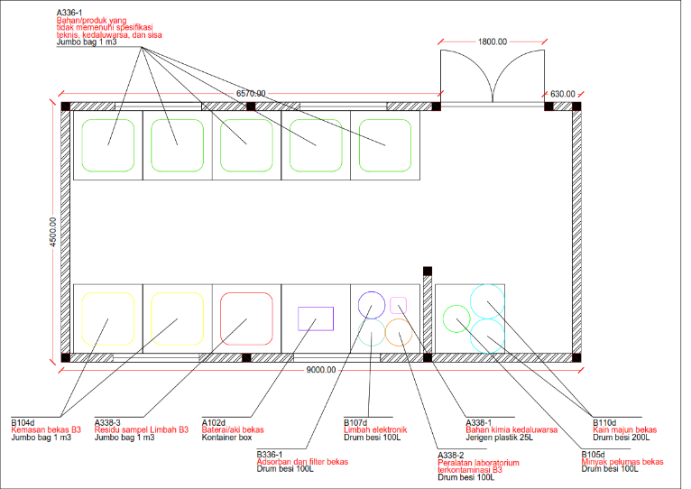

Figure 1. Top view of the waste temporary storage site

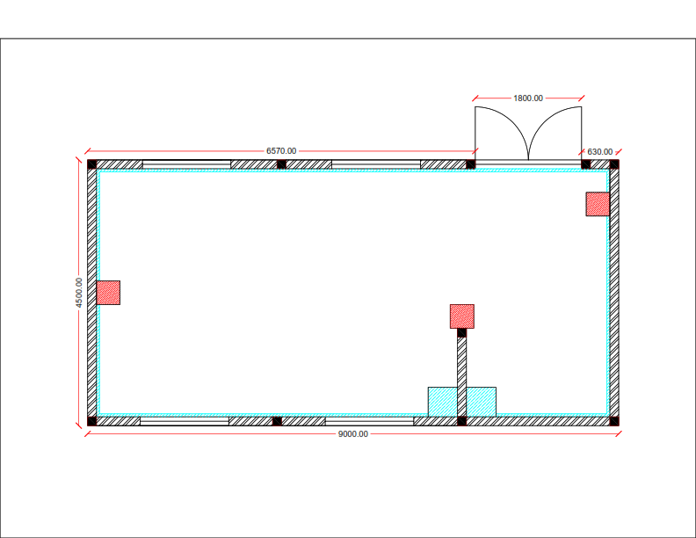

Figure 2. Top view of the waste temporary storage site catch basin/tub and APARs

The purpose of the catch basin/tub is to accommodate splashes from liquid phase B3 waste in the event of a leak or spill. To accommodate leak or splashes, the waste temporary storage site is also equipped with a drainage channel located around the inside of the TPS building which will later be accommodated in the catch basin (Naurah, 2025).

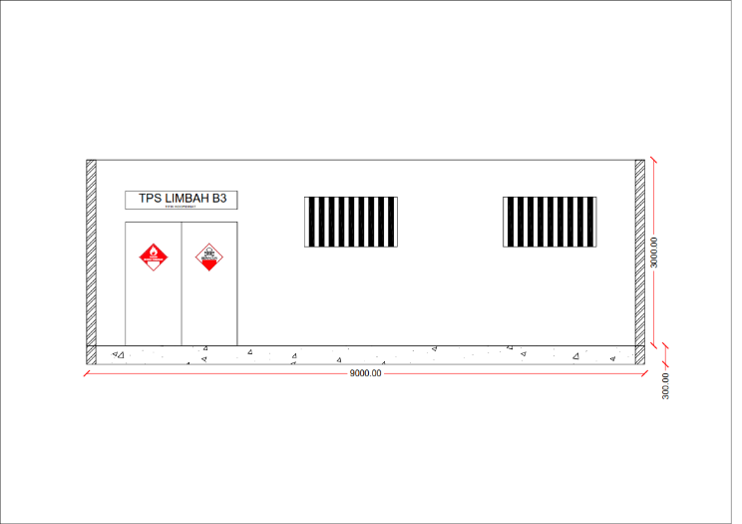

Figure 3. Front view of the waste temporary storage site

Symbols and labels are used to determine what B3 waste is in the packaging. Therefore, symbols and labels on packaging are things that are considered in re-planning the temporary storage of B3 waste and have been regulated in Permen LH No. 14 of 2013 (Ludfiyan, 2019).

# 4. Conclusion

The design and facilities of the new B3 waste temporary storage site have been made based on the applicable regulations and corrected the identified deficiencies. The B3 waste TPS building is designed based on Permen LHK No. 6 of 2021, SNI 03-6572-2001, Regulation of the Minister of Manpower and Transmigration of the Republic of Indonesia No. Per.04/Men/1980 and Regulation of the Minister of Manpower No. 5 of 2018.

The new B3 waste TPS building is designed to store 4 100L drums, 2 200L drums, 5 jumbo bags 1 m 3, 1 jerry can 25 L and a container box with a total of 11 pallets. The building height is measured from the floor as high as 3 m. From the redesign of the B3 waste temporary shelter, it is obtained that the B3 waste TPS building has improved the inaccurate application of regulations based on the results of evaluation according to regulations. So that these results can optimize the activities carried out from waste storage activities at the PT X’s B3 waste temporary storage site.

# References

A. A. Sidik, and E. Damanhuri. (2016). “Studi Pengelolaan Limbah B3 (Bahan Berbahaya dan Beracun) Laboratorium di ITB,” J. Tek. Lingkung, Vol. 18, No. 18.

A. Aiana, Ni’am. (2020). Identifikasi Limbah Bahan Berbahaya dan Beracun (B3) di Laboratorium PT XYZ. Jurnal Sains dan Teknologi, 8, 147.

A. Luqman, L. N. Ayomi, K. Fiqih, R. Syeida. (2023). Perencanaan Ulang Tata Letak dan Kebutuhan APAR pada Pabrik Karung Plastik. IJESPG Journal, Vol. 1, No. 3.

Badan Standarisasi Nasional (BSN). (2003). “SNI-03-6572-2001, Tata Cara Perancangan Sistem Ventilasi dan Pengkondisian Udara pada Bangunan Gedung.”

E. Wardhani, R. Rosmeiliyana. (2020). Identifikasi Timbulan dan Analisis Pengelolaan Limbah B3 di Pabrik Kertas PT X. *Jurnal Serambi Engineering*, 5(3).

H. Kusdiantoro, U. P. Astuti, and R. Dhani. (2014). “Redesain Tempat Penyimpanan Sementara (TPS) Limbah B3 Di Perusahaan Kapal,” 194-198.

I. Roza. (2022). Redesain Tempat Penyimpanan Sementara (TPS) Limbah Bahan Berbahaya dan Beracun (B3) pada PT Adhi Karya (Persero) Tbk Proyek Pembangunan Jalan Tol Ruas Sigli-Banda Aceh. *Tugas Akhir*. Universitas Islam Negeri (UIN) Ar-Raaniry Banda Aceh.

N. Fauziah, A. Syahfira, S. Kholijah. (2021). Evaluasi Standar Peletakan Alat Pemadam Kebakaran Ringan (APAR) di Kantor BPBD Provinsi Sumatera Utara. *Jurnal Pengabdian Kesehatan Masyarakat*, 1(2), 53-59.

Nurhayati, R. D., Purnomo, Y. S. (2023). Rencana Pengelolaan Limbah B3 Pada Industri Makanan Laut. EnviroUS, 4(1), 66–72.

P. Titin, Jayanta, and Yulnelly. (2017). Peran Data Primer pad Pembentukan Skema Konseptual yang Faktual. *Jurnal Simetris*, 8(2).

Peraturan Menteri Lingkungan Hidup dan Kehutanan No. 6 Tahun 2021, Tata Cara Persyaratan Pengelolaan Limbah B3.

Peraturan Menteri Tenaga Kerja dan Transmigrasi No. 4. (1980). “Syarat Pemasangan dan Pemeliharaan Alat Pemadam Api Ringan (APAR).”

Peraturan Pemerintah RI No. 22. (2021). Penyelenggaraan Perlindungan dan Pengelolaan Lingkungan Hidup.

R. Ludfiyan, A. Luqman, S. Vivin. (2019). Redesain Tempat Penyimpanan Sementara Limbah B3 pada Industri Asam Phospat di Kabupaten Gresik. *Conference Proceeding on Waste Treatment Technology*. ISSN No. 2623 – 1727.

R. Wisdayana, F. Sri, P. Pangesti, and A. Arlesmayana. (2022). “Redesain Tempat Penyimpanan Sementara Limbah B3 di Workshop PT. Purna Baja Harsco,” Serambi Engineering, VII.

Republik Indonesia. (2013). Peraturan Pemerintah No. 14 Tahun 2013 tentang Simbol dan Label Limbah Bahan Berbahaya dan Beracun. Sekretariat Negara. Jakarta.

S. Mukrimaa, S. Nurdyansyah, E. F. Fahyuni, A. Yulia Citra, N. D. Schulz, T. Taniredja, E. M. Faridli, and S. Harmianto. (2016). “Rancang Bangun Aplikasi Monitoring Tabung APAR (Alat Pemadam Api Ringan) Pada PT. Tirta Investama Plant Langkat Berbasis Android,” Jurnal Penelitian Pendidikan Guru Sekolah Dasar, 128.

Septemberina, A. Dian. (2016). Desain Ulang Gudang Penyimpanan Limbah Bahan Berbahaya dan Beracun (B3) di PT Petrowidada.

T. Naurah, W. Pranandito, A. Tuhu. (2025). Evaluasi Penyimpanan Sementara Limbah Bahan Berbahaya dan Beracun (B3) pada Industri Akumulator Listrik di Kecamatan Taman, Kabupaten Sidoarjo. *Globe: Publikasi Ilmu Teknik*. Vol 3 No. 1.

U. T. Khurnia, Syafrudin. (2018). Pengelolaan Limbah Bahan Berbahaya dan Beracun (B3) Studi Kasus PT Holcim Indonesia, Tbk Narogong Plant. *Jurnal Presipitasi*,15(2).